Experiment: Identification of HTML Tags Using LEX

Aim
To write a LEX program to identify and print all HTML tags present in a given HTML file.

Algorithm
- Start the program.
- Create an HTML file named input.html.
- Write a LEX program to recognize HTML tags.
- Open the HTML file using fopen().
- Use yylex() to scan the file and identify the tags.
- Print each identified HTML tag.
- Close the file and stop the program.

Pseudocode

BEGIN
Open input.html
IF file cannot be opened
Print error message
STOP
END IF

Read the file using the LEX scanner

WHILE HTML tags are found
Print the HTML tag
END WHILE

Close the file
END

HTML Input File (input.html)
<html>
<body>
<h1>Hello</h1>
</body>
</html>

LEX Program (html.l)
%{
#include <stdio.h>
%}

%%
"<"[^>]+">" { printf("HTML tag: %s\n", yytext); }
.|\n ;
%%

int yywrap(void)
{
return 1;
}

int main(void)
{
FILE *fp = fopen("input.html", "r");

if (fp == NULL)
{
printf("Error opening input.html\n");
return 1;
}

yyin = fp;
yylex();

fclose(fp);
return 0;
}

Input (input.html)
<html>
<body>
<h1>Hello</h1>
</body>
</html>

Output
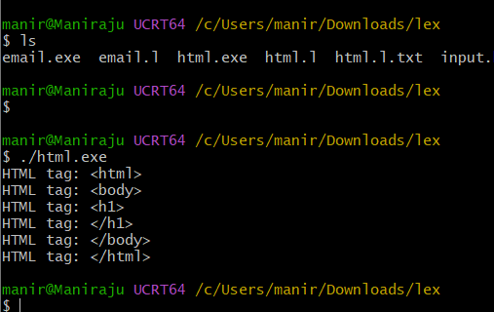

Result
Thus, the LEX program was successfully written and executed to identify and print all HTML tags present in the given HTML file.

